Latest Round-ups:
Season 2019/20
#12
Midweek Action: Roman Glass St George followed up their big comeback in the Vase three days earlier by beating Cribbs 6-2 at the Lawns. The first half saw plenty of goalmouth action at both ends, with Joe White and Jacob Hodgson each scoring for the home side to draw them level following a pair of strikes from Kye Simpson. A 62nd minute goal from Troy Simpson then put Roman Glass ahead for the third time, but there was no comeback from Cribbs on this occasion. Second half sub George Box extended the visitors lead, with Kye Simpson then completing his hat-trick ten minutes from time, before another substitute, Harry Haughton, fired home the Glass’s sixth goal of the night. Buckland Athletic claimed a 3-1 win away at Bridport in Tuesday’s other Premier Division fixture, with goals from Richard Groves, Nathan Cooper and Stuart Worker helping to end a run of back-to-back league defeats.
The following evening, Bradford Town extended their excellent start to the season, beating Brislington 6-1 at Trowbridge Road. After Tyson Pollard had gone close on a couple of occasions, the playmaker turned provider for Bradford’s opener, laying the ball off for Gary Higdon to fire home. Will Hailston then took over the contest, giving the Bobcats a two-goal lead at the break with his first goal since returning to the club. Hailston then struck twice more during the second period to complete his hat-trick, with goals from Lewis Powell and Higdon completing the one-sided victory. Exmouth Town were also big winners on Wednesday evening, hitting Street for five at the King George V Ground. Jordan Harris struck in either half for the Devonians, with Callum Shipton, Karl Rickard and Aaron Denny also getting in on the scoring to help Exmouth rack up their seventh consecutive win.
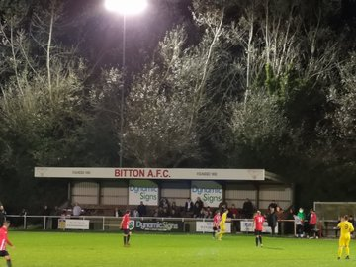
The Western League enjoyed twin successes in the FA Vase, with Bitton and Plymouth Parkway both progressing to the second round. Parkway secured a 3-1 win away at Romsey Town on Wednesday, with leading marksman Adam Carter striking in either half to make the long midweek trip a productive one for players and supporters alike. 24 hours earlier, Bitton produced a dominant performance, scoring three times in either half to beat Tadley Calleva 6-1 (pictured), setting up another home tie in the next round against Fairford Town.
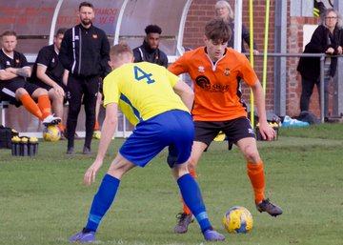
Premier Division: Captain Shane Krac starred for Plymouth Parkway, scoring twice during the league leaders 4-1 win at home to Shepton Mallet. Minus their blip against Keynsham a month ago, Parkway have been racking up high-scoring wins of late, and that was no different on Saturday afternoon where they started fast against Shepton. Having gone ahead inside the opening ten minutes through Mikey Williams, the score was doubled by Krac soon after, with top scorer Adam Carter then extending the lead to three. Mallet threatened a fightback after scoring at the end of the first half, but Krac’s excellent free kick just after the interval put the result beyond doubt. Bradford Town’s five-game winning run was brought to an end away at Cribbs, after the home side grabbed a stoppage-time equaliser to cap a 2-2 draw. Cribbs made a strong start to the game, with recent hat-trick hero George Kellow handing them a half-time lead. Town came out strongly in the second half, and after Tyson Pollard had equalised with a free-kick, they forged ahead when leading scorer Gary Higdon extended his scoring streak. The hosts had won three on the bounce prior to their big home defeat during the week, so they will have been mightily pleased to pick up a point against the high-flying Bobcats, with Jacob Hodgson striking in injury time to secure a share of the spoils. Bitton produced an excellent fightback at Bridgwater Town, overturning an early two-goal deficit to claim a 3-2 victory. The hosts made a brilliant start at Fairfax Park, with Harry Horton smashing them ahead in the sixth minute, before Steve Murray doubled their tally ten minutes later. Bitton worked their way into the game, halving the deficit thanks to goal from Aysa Corrick, with Karim Rendall then grabbing an equaliser five minutes before the interval. Corrick then played a huge role in the eventual game winner, beating a couple of defenders before laying the ball off for Matt Groves who completed the turnaround 12 minutes from time. Roman Glass St George are definitely a team on the rise, with their 6-1 win over Chipping Sodbury Town giving them their fourth win on the bounce. The home side made an electric start to the game, and after skipper Sam Wentland had headed them ahead inside 90 seconds, Ryan Radford was soon on target to double their advantage. George Box then got in on the action to make it 3-0 inside ten minutes, with Troy Simpson scoring twice toward the end of the first half to stretch the lead to five. The second half was a quieter affair, with Box adding a late sixth for Roman Glass to take their tally to 17 goals in their three victories over the last seven days. Keynsham Town picked up a vital three points, with a first half Ben Harris goal, and just their second clean sheet of the season leading them to a 1-0 victory at home to Exmouth Town. Wellington were rewarded for playing until the final whistle, scoring in injury time to draw 1-1 with Cadbury Heath (pictured right). Having trailed for much of the second half after Enis Akgun had put the visitors ahead, Wellington claimed a late point thanks to a cross-come-shot from Paolo Borges which ended up in the Cadbury Heath net.
There was also a 1-1 draw in Devon, where Westbury’s Mark Robinson flicked the ball home during the final ten minutes to deny Tavistock who had led for the majority of the contest. Buckland Athletic captured their third away win of the week, following up victories against Camelford and Bridport with a 2-0 triumph over Street thanks to second half goals from Stuart Bowker and Richard Groves. There was celebration for Bridport, who captured their first home win of the season at the seventh time of asking, with Lewis Clarke’s goal eight minutes into the second half leading them to a 1-0 win over Hallen. At the Hand Stadium, Clevedon were consigned to a fourth consecutive defeat, after goals in either half from Neikell Plummer and Kristian Miller led Brislington to a 2-0 victory over the Seasiders.
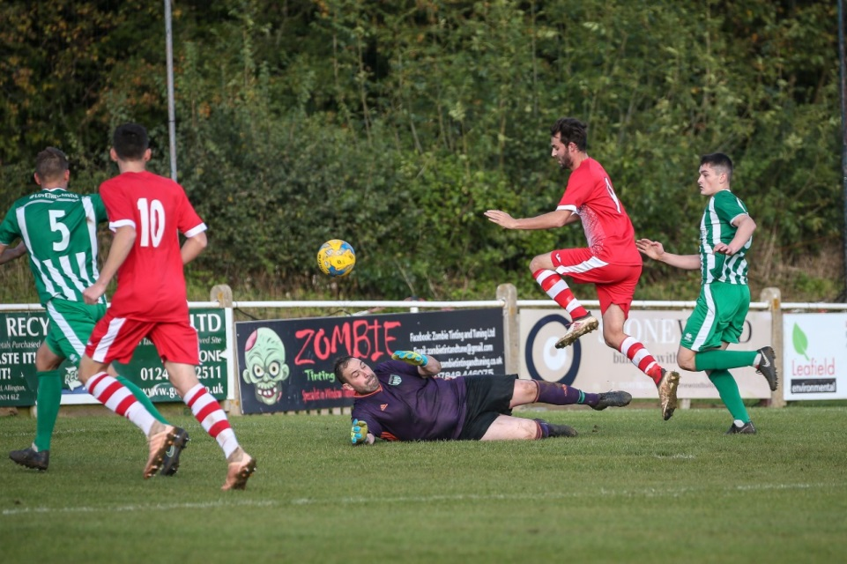
First Division: Wells City made an excellent start to the weekend, beating Oldland Abbotonians 4-1 on Friday evening. Oldland have one of the sternest defences in the First Division, but they Wells seem to have their number, having now registered 4-1 victories in both of their league meetings this season. The scoring got underway early at the Athletic Ground, with Kieran Davis producing a belting finish to put the home side one up inside three minutes. Oldland hit back on the quarter hour mark, with Scott Robson squeezing his penalty attempt under the Wells keeper following a foul on Owen McCallum in the box. Dale Hunt then restored City’s advantage with a well-taken free kick, before leading scorer Harry Foster made it 3-1 in the lead-up to half time. The second half was quieter in terms of goalscoring opportunities, with Tom Hill the only man to hit the target for Wells to help them complete an early-season double over the Abbots. Calne Town may sit top of the table, but their 2-1 win away at Welton Rovers came in difficult circumstances, being forced to come from behind, while also suffering a late dismissal when the game was still level. Welton’s 14th minute opener from Dylan Hatt had seen them lead for much of the game, before Jake Allen equalised from the spot following a foul on Dan Sibley 20 minutes from time. Calne were then reduced to ten men after Oscar Webster was shown his second yellow card, but the underhanded visitors managed to snatch all three points during the final five minutes when Stuart Windsor nodded the ball home. Second-placed Wincanton also trailed before storming back to defeat Bristol Telephones 4-1. Having gone behind, Wincanton came to life at the end of the first half, with Toby Cole levelling affairs, before Dan Wise fired home a sweetly struck free kick less than two minutes later to put them ahead at the break. Town then pushed on during the second period, with Louis Irwin extending their advantage, before Wise wrapped up victory in the closing stages with his second set piece of the afternoon. Longwell Green Sports continued their fine run of form with a 2-1 win away at Cheddar. Having seen Adam Wright cancel out Aidan Sanfelice’s opener, Longwell Green hit back, with the in-form Danny Carter striking a late winner from the penalty spot. In one of the most entertaining games of the day, Radstock managed to hold off a battling Sherborne to eventually claim a 3-2 victory at Raleigh Grove. Goals from Jack Biddiscombe and James Rustell had twice put Radstock ahead, but their resilient hosts hit back on both occasions, with Dan Newens and then Anthony Herrin scoring equalisers. The Miners winning goal came midway through the second half, with youngster Mason Harrison finishing off an excellent team goal to make it five wins from six in all competitions. Lebeq United are the only team to have beaten Radstock in recent times, and they themselves now have three victories from their last four games after strikes from Elan Plummer, James Hall and Twaine Plummer helped them beat Hengrove 3-0. Substitute Lewis McCarron bagged a late brace to confirm Corsham’s 4-1 comeback victory over Almondsbury. After Dan Lane had put the visitors ahead in the opening half, a volleyed finish from James Gardner levelled the scores, before Ash Alchin put Corsham ahead in first half stoppage time. With the points still up for grabs in the closing stages, McCarron eased the hosts nerves, extending Corsham’s lead six minutes from time, before then adding their fourth goal two minutes later to end any hopes the Almonds had of a late salvo. The points had to be shared at Bristol Road, where Devizes came back from a two-goal deficit to draw 2-2 with Portishead. In a wild ending to the first half, Callum Eastwood and then Alex O’Keefe struck in quick succession to give the home side command of the game, before Matt Russell handed Devizes a lifeline in the second minute of added time. The away side came out refreshed in the second half, with the draw specialists tying their opponents for the fourth time in five games thanks to a 62nd minute header from Matty Lever. Ashton & Backwell United remain one of the form sides in the league, surviving a late setback to beat Warminster Town 2-1 at the Lancer Scott Stadium. Backwell are now unbeaten in eight league matches, and went ahead against Warminster when James White smashed the ball home two minutes before the break following a pull back from Charlie Saunders. As the hour mark approached, Warminster saw skipper Charlie Walton sent to the sin-bin, but incredibly they managed to equalise during the period where they were down to ten men. The home side managed to regroup, and just as though it looked as though they may have fluffed their lines, Saul Jarrett struck 15 minutes from time to hand them all three points. In the battle of the Bishop’s, Lydeard managed to overcome Sutton by three goals to two at Lakeview. Goals inside the opening 15 minutes from Ryan Brereton and Sam Mockridge for Lydeard were cancelled out by the hosts, before Ben Hebditch volleyed home from Joe Chamberlain’s knock-down to complete the victory.
Action from Corsham’s 4-1 comeback win over Almondsbury.
Image courtesy of John Cuthbertson.

Western League Statistical Leaders

PREMIER DIVISION LEADING GOAL SCORERS (League only):
Adam Carter (Plymouth Parkway) – 17
Jack Taylor (Bridgwater Town) – 9
Jack Fillingham (Shepton Mallet) – 9
Lucas Vowles (Clevedon Town) – 9
Josh Egan (Bitton) – 9

PREMIER DIVISION TOP ATTENDANCES:
Bridport 0 Bridgwater Town 6, Sunday 6th October 2019 – 347
Wellington 0 Exmouth Town 2, Sunday 6th October 2019 - 315
Plymouth Parkway 1 Exmouth Town 0, Wednesday 21st August 2019 - 308

FIRST DIVISION LEADING GOAL SCORERS (League only):
James Rustell (Radstock Town) – 14
Harry Foster (Wells City) – 11
Stuart Windsor (Calne Town) – 10
Adam Wright (Cheddar) – 8

FIRST DIVISION TOP ATTENDANCES:
Warminster Town 2 Bristol Telephones 3, Saturday 5th October - 369
Portishead Town 3 Longwell Green Sports 5, Saturday 5th October – 262
Devizes Town 0 Ashton & Backwell United 1, Saturday 5th October – 252

LEADING SCORERS IN ALL COMPETITIONS:
Jack Crago (Tavistock) - 20
James Rustell (Radstock Town) – 19
Adam Carter (Plymouth Parkway) – 17
Harry Foster (Wells City) – 14
Gary Higdon (Bradford Town) – 13
Jack Taylor (Bridgwater Town) - 12
Jack Fillingham (Shepton Mallet) – 12
Lucas Vowles (Clevedon Town) – 11
Stuart Windsor (Calne Town) – 11

Be sure to check out the latest podcast, where Ian, Tom & guests recap all the latest news and results from around the Western League. To follow along all season, each broadcast will be available at the following link: http://www.toolstationleague.com/podcasts.php

*All goalscoring stats via
Full-Time FA website

Latest Results
Tuesday 15th October 2019
FA Vase – First Round
Bitton 6-1 Tadley Calleva 135
Premier Division
Bridport 1-3 Buckland Athletic 99
Cribbs 2-6 Roman Glass St George
Wednesday 16th October 2019
FA Vase – First Round
Romsey Town 1-3 Plymouth Parkway
Premier Division
Bradford Town 6-1 Brislington 113
Exmouth Town 5-0 Street 161
Friday 18th October 2019
First Division
Wells City 4-1 Oldland Abbotonians 58
Saturday 19th October 2019
Premier Division
Bridgwater Town 2-3 Bitton 256
Bridport 1-0 Hallen 95
Clevedon Town 0-2 Brislington 109
Cribbs 2-2 Bradford Town 89
Keynsham Town 1-0 Exmouth Town 163
Plymouth Parkway 4-1 Shepton Mallet 178
Roman Glass St George 6-1 Chipping Sodbury Town 60
Street 0-2 Buckland Athletic 70
Tavistock 1-1 Westbury United
Wellington 1-1 Cadbury Heath 51
First Division
Ashton & Backwell United 2-1 Warminster Town 86
Bishop Sutton 2-3 Bishops Lydeard 35
Cheddar 1-2 Longwell Green Sports 75
Corsham Town 4-1 Almondsbury 78
Hengrove Athletic 0-3 Lebeq United 54
Portishead Town 2-2 Devizes Town 41
Sherborne Town 2-3 Radstock Town 71
Welton Rovers 1-2 Calne Town 82
Wincanton Town 4-1 Bristol Telephones 40

Upcoming Fixtures
Tuesday 22nd October 2019
Premier Division
Brislington vs Cribbs 19:30KO
Buckland Athletic vs Plymouth Parkway 19:30KO
Chipping Sodbury Town vs Keynsham Town 19:45KO
Hallen vs Odd Down 19:30KO
Shepton Mallet vs Cadbury Heath 19:30KO
Street vs Bridport 19:30KO
First Division
Wells City vs Cheddar 19:30KO
Wednesday 23rd October 2019
Premier Division
Bradford Town vs Bitton 19:30KO
Exmouth Town vs Tavistock 19:30KO
Westbury United vs Bridgwater Town 19:30KO
First Division
Bishops Lydeard vs Warminster Town 19:30KO
Saturday 26th October 2019 (KICK OFF AT 3.00PM UNLESS NOTED)
Premier Division
Bitton vs Keynsham Town
Bridgwater Town vs Buckland Athletic
Bridport vs Bradford Town
Cadbury Heath vs Roman Glass St George
Chipping Sodbury Town vs Shepton Mallet
Exmouth Town vs Brislington
Odd Down vs Clevedon Town
Plymouth Parkway vs Westbury United
Tavistock vs Hallen
Wellington vs Street
First Division
Almondsbury vs Wells City
Bishop Sutton vs Sherborne Town
Bishops Lydeard vs Radstock Town
Bristol Telephones vs Ashton & Backwell United
Cheddar vs Welton Rovers
Devizes Town vs Oldland Abbotonians
Lebeq United vs Corsham Town
Longwell Green Sports vs Hengrove Athletic
Portishead Town vs Calne Town
Warminster Town vs Wincanton Town

League Tables
Premier Division
 |  | P | W | D | L | F | A | GD | PTS
1 | Plymouth Parkway | 10 | 8 | 1 | 1 | 43 | 8 | 35 | 25
2 | Bradford Town | 10 | 8 | 1 | 1 | 28 | 12 | 16 | 25
3 | Bridgwater Town | 10 | 6 | 2 | 2 | 34 | 14 | 20 | 20
4 | Exmouth Town | 8 | 6 | 0 | 2 | 18 | 3 | 15 | 18
5 | Bitton | 9 | 6 | 0 | 3 | 28 | 14 | 14 | 18
6 | Brislington | 13 | 6 | 0 | 7 | 22 | 33 | -11 | 18
7 | Westbury United | 10 | 5 | 2 | 3 | 20 | 16 | 4 | 17
8 | Hallen | 11 | 5 | 2 | 4 | 21 | 24 | -3 | 17
9 | Clevedon Town | 11 | 5 | 1 | 5 | 23 | 27 | -4 | 16
10 | Buckland Athletic | 10 | 5 | 0 | 5 | 17 | 18 | -1 | 15
11 | Street | 11 | 5 | 0 | 6 | 21 | 25 | -4 | 15
12 | Cribbs | 12 | 4 | 2 | 6 | 16 | 29 | -13 | 14
13 | Shepton Mallet | 8 | 4 | 1 | 3 | 18 | 14 | 4 | 13
14 | Cadbury Heath | 12 | 3 | 4 | 5 | 17 | 25 | -8 | 13
15 | Roman Glass St George | 9 | 4 | 0 | 5 | 25 | 12 | 13 | 12
16 | Tavistock | 7 | 3 | 2 | 2 | 17 | 12 | 5 | 11
17 | Keynsham Town | 9 | 3 | 2 | 4 | 19 | 22 | -3 | 11
18 | Wellington | 12 | 3 | 1 | 8 | 15 | 31 | -16 | 10
19 | Odd Down | 11 | 3 | 1 | 7 | 13 | 29 | -16 | 10
20 | Bridport | 13 | 3 | 1 | 9 | 19 | 37 | -18 | 10
21 | Chipping Sodbury Town | 12 | 2 | 1 | 9 | 13 | 42 | -29 | 7

First Division
 |  | P | W | D | L | F | A | GD | PTS
1 | Calne Town | 11 | 7 | 2 | 2 | 19 | 7 | 12 | 23
2 | Wincanton Town | 10 | 6 | 2 | 2 | 24 | 17 | 7 | 20
3 | Wells City | 10 | 6 | 1 | 3 | 27 | 16 | 11 | 19
4 | Longwell Green Sports | 10 | 6 | 1 | 3 | 23 | 17 | 6 | 19
5 | Ashton & Backwell United | 10 | 5 | 4 | 1 | 16 | 12 | 4 | 19
6 | Radstock Town | 10 | 6 | 0 | 4 | 25 | 20 | 5 | 18
7 | Oldland Abbotonians | 11 | 4 | 4 | 3 | 10 | 13 | -3 | 16
8 | Corsham Town | 11 | 5 | 1 | 5 | 22 | 31 | -9 | 16
9 | Cheddar | 9 | 5 | 0 | 4 | 18 | 14 | 4 | 15
10 | Lebeq United | 10 | 5 | 0 | 5 | 22 | 21 | 1 | 15
11 | Sherborne Town | 9 | 5 | 0 | 4 | 18 | 18 | 0 | 15
12 | Bishops Lydeard | 9 | 4 | 1 | 4 | 19 | 14 | 5 | 13
13 | Portishead Town | 9 | 4 | 1 | 4 | 24 | 20 | 4 | 13
14 | Almondsbury | 10 | 4 | 1 | 5 | 16 | 18 | -2 | 13
15 | Devizes Town | 10 | 2 | 4 | 4 | 20 | 20 | 0 | 10
16 | Welton Rovers | 10 | 3 | 1 | 6 | 12 | 21 | -9 | 10
17 | Warminster Town | 9 | 3 | 0 | 6 | 18 | 16 | 2 | 9
18 | Hengrove Athletic | 10 | 2 | 3 | 5 | 6 | 26 | -20 | 9
19 | Bishop Sutton | 10 | 2 | 1 | 7 | 13 | 19 | -6 | 7
20 | Bristol Telephones | 10 | 1 | 1 | 8 | 14 | 26 | -12 | 4

